What will we be learning?  Unit FO91 – Anatomy & Physiology for health and social care | Why this? Why now?  This unit is completed in Year 13. It is a compulsory unit. It runs alongside F094 and F097 the coursework units delivered during Year 13. | Key Words/terms:  See key words glossary for each system
What will we learn?
- TA1 – Cardiovascular system
- TA2 – Respiratory system
- TA3 – Digestive system
- TA4 – Musculoskeletal system
- TA5 – Control and regulatory systems
- TA6 – Reproductive system

What opportunities are there for wider study?
Careers/degree courses
- Social care
- Childcare
- Health care

Further reading:
Describe different working relationships in care settings – DSDWEB: FREE STUDY GUIDES FOR CARE QUALIFICATIONS
Timeline of Baby P case - BBC News
Inquiry investigates deaths of 1,500 NHS mental health patients in Essex | Mental health | The Guardian
How will I be assessed?
- OCR set external examination
AAQ – HEALTH & SOCIAL CARE
UNIT F091

TA1 – CARDIOVASCULAR SYSTEM  - Composition and functions of blood  - The heart  - Blood vessels  - Conditions of the cardiovascular system – angina and deep vein thrombosis (DVT) | 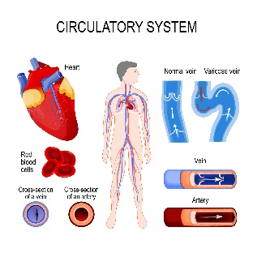
TA2 – RESPIRATORY SYSTEM  2.1 Structure and function of the respiratory system  2.2 Cellular respiration  2.3 Conditions of the respiratory system – asthma and bacterial pneumonia | 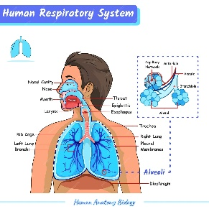
TA3 – DIGESTIVE SYSTEM  - Structure and function of the digestive system  - Mechanical and chemical digestion  - Absorption and assimilation  - Conditions of the digestive system – bowel polyps and gallstones | 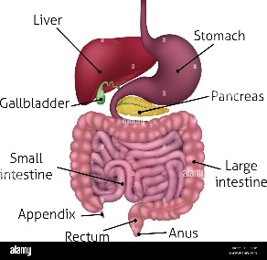
TA4 – MUSCULOSKELETAL SYSTEM  4.1 Skeletal system  4.2 Muscular system  4.3 Conditions of the musculoskeletal system – carpal tunnel syndrome and osteoarthritis | 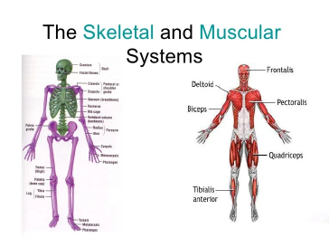
TA4 – CONTROL AND REGULATORY SYSTEMS  4.1 The nervous system  4.2 Homeostasis  4.3 Conditions of the control and regulatory systems – ischaemic strokes and type 2 diabetes | 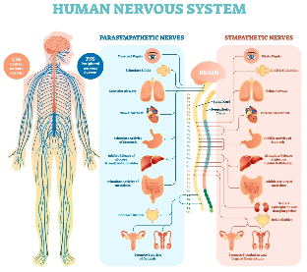
TA4 – REPRODUCTIVE SYSTEM  4.1 Female and male reproductive systems  4.3 Conditions of the control and regulatory systems – endometriosis and testicular cancer | 